Dunman High School
2010 Year 6 H2 Chemistry Preliminary Exam – Paper 3 Answers

1(a) | Aluminium is the world’s most abundant metal and is the third most common element, comprising 8% of the earth’s crust. The versatility of aluminium makes it the most widely used metal after steel. Although aluminium compounds have been used for thousands of years, aluminium metal was first produced around 170 years ago.  - It is possible to ionised aluminium to form aluminium negative ion Al– in the gaseous state. Give a balanced equation for this reaction.  Al (g) + e → Al– (g)  - What is the name of the reaction in (i)?  First electron affinity of aluminium  - Give the full electronic configuration of Al–.  1s² 2s² 2p⁶ 3s²  - How would you expect the magnitude of the enthalpy change of the reaction in (i) compared to that of sodium? Explain as fully as you can.  - The magnitude of the first electron affinity for aluminium will be smaller/lower than that of sodium.  - The nuclear charge of aluminium is higher than sodium  - The filled inner s subshell of aluminium provides effective shielding for the additional electron as compared to sodium.  - The additional electron of aluminium resides in a p–orbital which is further than the electron in a s–orbital of sodium.  [6]
(b) | Solid aluminium chloride sublimes at 6000°C. When 1.00 g of the solid is placed in an evacuated vessel of volume 1.00 dm³ at 6000°C, the pressure produced is 207.7 kPa.  - Calculate the apparent relative molecular mass of the aluminium chloride under these conditions.  207.7 × 10³ × 1 × 10^{–3} = 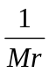 × 8.31 × (6000 + 273)  M_{r} = 251  - Assuming that, in the vapour phase, aluminium chloride partially exists as dimer, calculate the percentage of the dimer under these conditions.  x(133.5) + (1–x)(267) = 251  x = 0.12  percentage of dimer = 88.0% (3 s.f.)  - Draw the dot and cross diagram for the dimer of aluminium chloride.  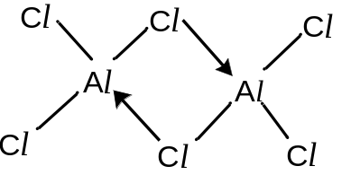  [4]
(c) | The Gattermann–Koch reaction, named after the German chemists Ludwig Gattermann and Julius Arnold Koch in organic chemistry refers to a Friedel–Crafts acylation reaction in which carbon monoxide and hydrochloric acid are used in–situ with Friedel–Crafts catalyst, namely AlCl₃. The reaction involves an acylium ion as an electrophile and tetrachloroaluminate ion, AlCl₄–. An example is provided below.  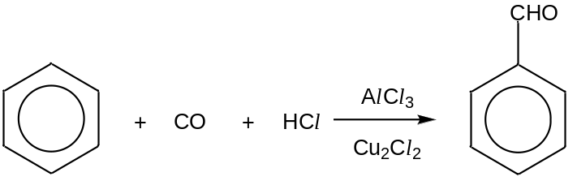  - Define the term electrophile.  An electrophile is any species that accepts an electron pair with a vacant orbital/ is an electron pair acceptor  - Give the forumla of the acylium ion in this reaction.  CHO⁺  - State the type of reaction and describe the mechanism of Gattermann–Koch reaction (You may omit the step that generates the acylium ion).  Electrophilic substitution.  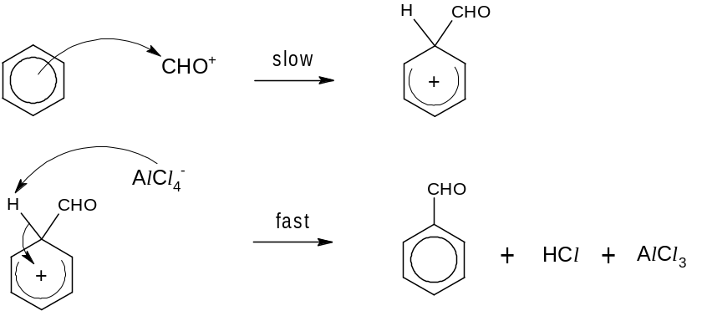  [6]
(d) | The synthesis of compound C involves the Gattermann–Koch reaction in Step II. Complete the reaction scheme below by providing the appropriate reagents and conditions for  Step I and IV and give the structural formula for A – B.  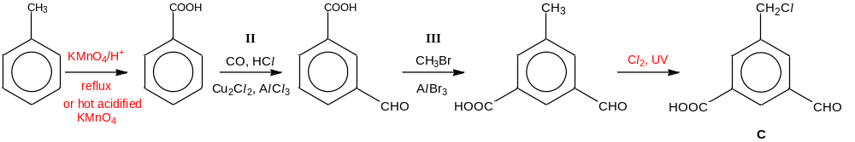  [4]  [Total: 20]
2(a) | Methane is used to produce synthesis gas (syngas), a mixture that includes carbon monoxide and hydrogen, by reacting with steam on a nickel catalyst. Syngas is then used to produce liquid hydrocarbons and methanol.  CH₄ (g) + H₂O (g) CO (g) + 3H₂ (g)  When a 1:1 ratio of methane and steam at a total initial pressure of 10 atm is mixed, 50% conversion is achieved.  - Write an expression for the equilibrium constant, K_{p}, and determine its value, including units.  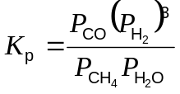  = 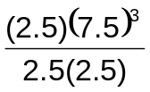= 168.75 ≈ 169 atm²  - It is known that this reaction is an endothermic process. What is meant by the term in italics?  Endothermic means that heat/energy is absorbed from the surrounding.  - Predict and explain the effect of separately increasing pressure and decreasing temperature on the above equilibrium as well as on the yield.  On increasing the pressure,  by Le Chatelier’s Principle, the position of equilibrium will shift to the left to reduce the total number of moles of gas .  On decreasing the temperature,  by Le Chatelier’s Principle, the position of equilibrium will shift to the left towards the exothermic reaction to release heat.  In both cases, yield decreases.  - In practice, a moderately high pressure is used in the production of syngas. Suggest a reason for this.  Using too high a pressure is expensive / costly due to thick pipes needed , or  it increases rate of reaction , or  too high a pressure will result in low yield,  hence a moderately high pressure is used instead.  - Sketch a graph showing how the rates of the forward and reverse reactions change with time, from the point of mixing to the point after equilibrium is established. Label your graphs clearly.  forward  rate  time  At t_{eqm}:  Rate of forward = rate of backward reaction  backward  t_{eqm}  - Correct axis + labels  - Correct curve shape  - Label t_{eqm} correctly  [11]
   | CH₄ (g) + | H₂O (g) |  | CO (g) + | 3H₂ (g)
  Initial P | 5 | 5 |  | 0 | 0
  Eqm P | 5 – 50%(5) = 2.5 | 2.5 |  | 2.5 | 3(2.5) = 7.5
(b) | To manufacture methanol, the carbon monoxide and hydrogen mixture is passed over a mixutre of copper, zinc oxide and alumina catalyst. Besides being a common laboratory solvent, the largest use of methanol (CH₃OH) is to produce methanal (HCHO).  - Industrially, oxygen is used to react with methanol to produce methanal. Write an equation for this reaction.  CH₃OH + ½O₂ → HCHO + H₂O  - Alternatively, what reagent and condition can be used in the laboratory to convert methanol to methanal?  K₂Cr₂O₇ in dilute H₂SO₄, heat with distillation  - Sketch the shapes of the hybrid orbitals around each carbon in the methanol and methanal molecule.
  CH₃OH: | HCHO:
   | 
  sp³ | sp²
(c) | Methane reacts with a chlorinating agent, sulfur dichloro dioxide (SO₂Cl₂) by a free–radical mechanism to yield choromethane in the following equation.  CH₄ + SO₂Cl₂ → CH₃Cl + CH₃SO₂Cl + SO₂ + HCl  - The initiation stage of this reaction occurs in two steps, both of which form the chlorine radical. Write an equation for each step at this stage.  Initiation:  SO₂Cl₂ → Cl• + SO₂Cl•  SO₂Cl• → Cl• + SO₂  - Propose two equations to represent the propagation stage of this reaction.  Propagation:  CH₄ + Cl• → CH₃• + HCl  CH₃• + SO₂Cl₂ → CH₃Cl + SO₂Cl•  - Given that CH₃SO₂Cl is produced at the termination stage, write the formulae of the radicals that produce it.  SO₂Cl• and CH₃•  [5]  [Total: 20]
3(a) | The dry cell battery is commonly used in portable devices such as handphones and torch lights. It is a non–rechargeable battery, with zinc electrode coated with Zn(OH)₂ and solid MnO₂ coated on carbon electrode. During the discharging process, MnO₂ is converted to MnO(OH) solid and hydroxide ions. The relevant redox half–equations are given in the table.
  Half–equation | Eº / V
  MnO₂ + e⁻ + H₂O 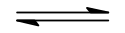 MnO(OH) + OH⁻ | + 0.84
  Zn(OH)₂ + 2e Zn + 2OH– | – 0.76
Platinised Pt electrode  [H⁺(aq)] = 1 mol dm^{–3} | - By means of a fully labeled diagram, describe how the value of the standard electrode potential of the Zn(OH)₂/Zn system can be confirmed.  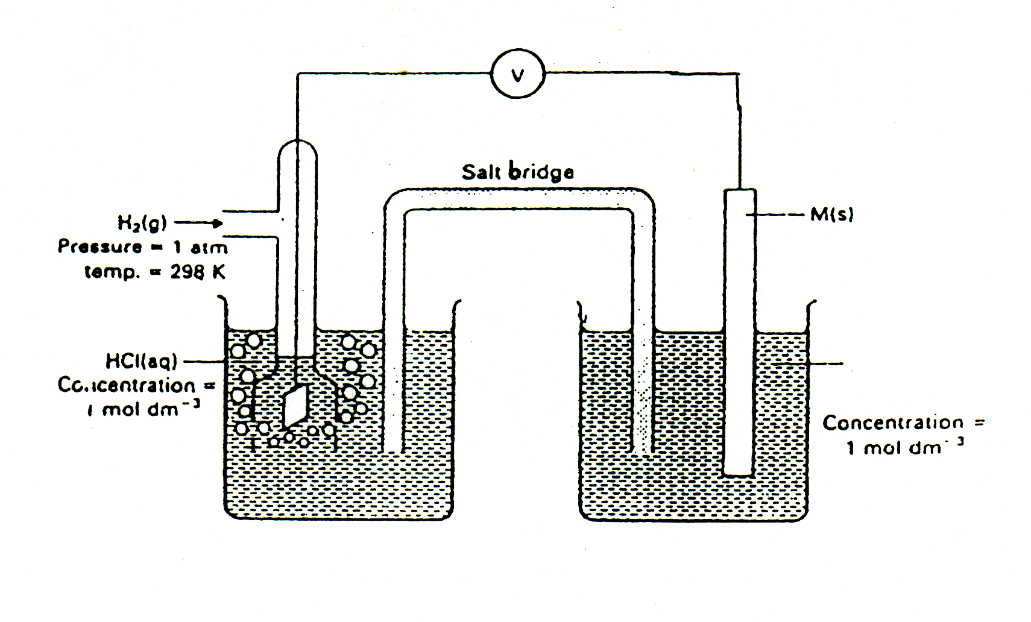  Pt(s)  Fe³⁺(aq), Fe²⁺ (aq)  H₂(g) at 298K and 1 atm  [H⁺(aq)] = 1 mol dm^{–3}  [OH–(aq)]= 1 mol dm^{–3}  Zn electrode  Coated with Zn(OH)₂ (s)  The standard hydrogen electrode potential of the Zn(OH)₂/ Zn system is measured with reference to the standard hydrogen electrode which has a potential of 0.00 V.  The standard Zn(OH)₂/ Zn half–cell is connected to the standard hydrogen electrode by a salt bridge.  From the voltmeter reading at 25ºC, E^{θ}_{cell} is found to be −0.76 V, indicating that oxidation occurs at the Zn(OH)₂/ Zn half–cell. The standard electrode potential for Zn(OH)₂/ Zn is therefore −0.76 V.  - Write an overall equation for the discharging reaction and calculate the e.m.f of the dry cell.  Zn + 2MnO₂ + 2H₂O → Zn(OH)₂ + 2MnO(OH)  Must be single arrow  Eº = +0.84 –(–0.76) = +1.60V  - hat happens to the e.m.f. of the dry cell when water is added to the zinc half cell? Explain your answer.  When water is added, concentration of OH– decreases.  Zn(OH)₂ + 2e Zn + 2OH– (2)  By Le Chatelier’s Principle, equilibrium (2) shifts to the right to increase the concentration of OH–.  Eº_{ox} becomes more positive/increases. Hence Eº_{cell} becomes less positive/decreases.  - State one advantage of using this dry cell over a lead–acid accumulator.  Light and portable.  - Explain why compounds of zinc are colourless.  The d–orbitals of Zn²⁺ are fully filled.  Therefore d–d transition is not possible/no d electrons are promoted to higher d–orbital or absorption of visible light can take place.  [11]
(b) | Besides their use in dry cell batteries, compounds of manganese also have applications in organic chemistry. In particular, potassium manganate(VII) is a useful oxidising agent.  When methanal, HCHO, is reacted with acidified potassium manganate(VII), methanoic acid and manganese(II) ions are formed. The overall equation for the reaction is:  2MnO₄–(aq) + 5HCHO(aq) + 6H⁺(aq) → 2Mn²⁺(aq) + 5HCOOH(aq) + 3H₂O(l)  The methanoic acid formed can be further oxidised to carbon dioxide.  At room temperature, the reaction proceeds at a slow rate. A few crystals of vanadium(III) nitrate are added to the mixture to speed up the reaction, which results from the formation of vanadate(IV) ions, VO²⁺, as intermediate.  - Calculate the oxidation number of carbon in HCOOH.  Oxidation no. of C in HCOOH = 0 – [2+2(−2)] = +2  Carbon is more electronegative than hydrogen, hence oxidation state of hydrogen = +1.  - Briefly describe the role of vanadium(III) ions in this reaction  V³⁺ acts as homogeneous catalyst,  by providing an alternative pathway with lower activation energy.  - Referring to relevant values from the Data Booklet and from the data given, show how vanadium(III) ions act as a catalyst in the reaction. Include balanced equations in your answer.  Step 1:  Reduction: MnO₄– + 8H⁺ + 5e → Mn²⁺ + 4H₂O  Oxidation: (V³⁺ + H₂O → VO²⁺ + 2H⁺ + e) x5  MnO₄– + H₂O + 5V³⁺ → Mn²⁺ + 5VO²⁺ + 2H⁺ (Single arrow)  E^{θ}_{cell} = +1.52 – (+0.34) = + 1.18V  Since E^{θ}_{cell} >0, reaction is feasible.  Step 2:  Reduction: (VO²⁺ + 2H⁺ + e → V³⁺ + H₂O) x2  Oxidation: HCHO + H₂O → HCOOH + 2H⁺ + 2e  2VO²⁺ + 2H⁺ + HCHO → 2V³⁺ + HCOOH + H₂O  E^{θ}_{cell} = +0.34 – (–0.03) = +0.37 V  Since E^{θ}_{cell} >0, reaction is feasible [4]
(c) | In an attempt to produce manganese metal, a student carried out the electrolysis of an aqueous solution of manganese(II) sulfate  - Predict the product(s) of the reaction at the cathode. Explain your reasoning using data from the Data Booklet.  2H₂O + 2e H₂+ 2OH– Eº = –0.83V  Mn²⁺ + 2e Mn Eº = –1.18 V  As the reduction potential for H₂O/ H₂ is less negative than that for Mn²⁺/ Mn, products at cathode are hydrogen gas and hydroxide ions.  - Calculate the current needed to pass through a solution of manganese(II) sulfate to produce 0.1 g per hour of the product at the cathode.  No. of mole of H₂ = 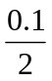= 0.05  0.05= 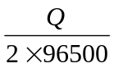  Q = 9.65 x 10³ C  I = 9650/ (60x60) = 2.68 A
4(a) | Caprolactam, C₆H₁₁NO, is a cyclic precursor to nylon 6, a widely used synthetic polymer.  An undergraduate student attempts to prepare caprolactam using 6–aminohexanoyl chloride, H₂N(CH₂)₅COCl.
(i) Draw the structural formula of caprolactam which might be obtained from
6–aminohexanoyl chloride. Name the type of reaction that is involved.

Nucleophilic substitution.
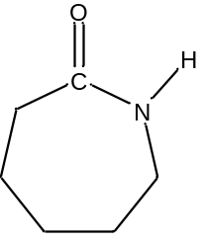
(ii) In the presence of 5 – 10% water and heating 6–aminohexanoyl chloride to about
80°C, the student isolated compound A, which has a molecular formula of C₁₂H₂₄N₂O₃, instead of caprolactam. Upon prolonged heating at a higher temperature of 250 °C, compound A is converted to a polymer, nylon 6. The structure of nylon 6 is shown below.
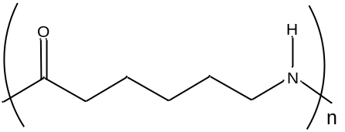
nylon 6

Draw the structural formula of compound A.

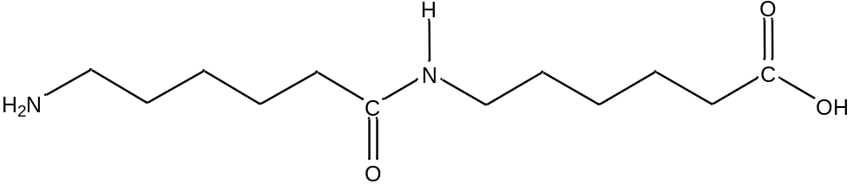

A dimer might be obtained with the reactive –COCl group hydrolysed by the water present to form a –COOH group.

(iii) The step–growth polymer nylon 6 can be hydrolysed to its monomer. Suggest a possible structural formula for its monomer and state the necessary reagent and condition for the conversion.

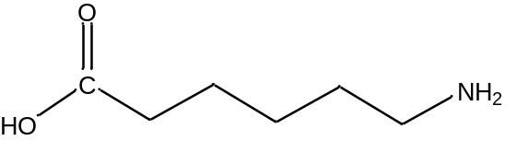

H⁺(aq), heat followed by careful addition of OH–(aq) or OH–(aq), heat followed by careful addition of H⁺(aq)

OR

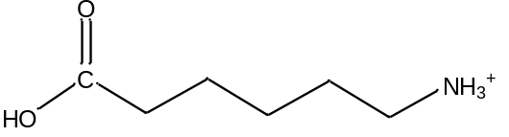

H⁺(aq), heat

OR
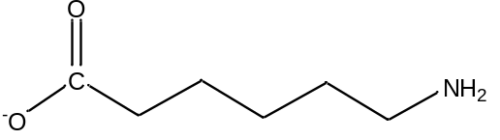

OH–(aq), heat
[5]

(b) | Phenyl–4–aminosalicylate is a drug used in the treatment of tuberculosis. It can be synthesised from 4–nitrosalicylic acid.  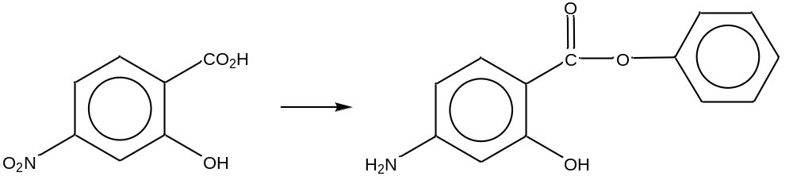  4–nitrosalicylic acid phenyl–4–aminosalicylate  Phenyl–4–aminobenozate, 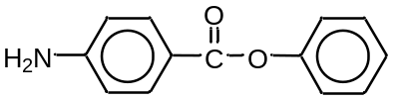, a structural analogue of phenyl–4–aminosalicylate, can be prepared in a similar way from 4–aminobenzoic acid.  (i) Outline how phenyl–4–aminobenzoate may be produced from 4–nitrobenzoic acid.  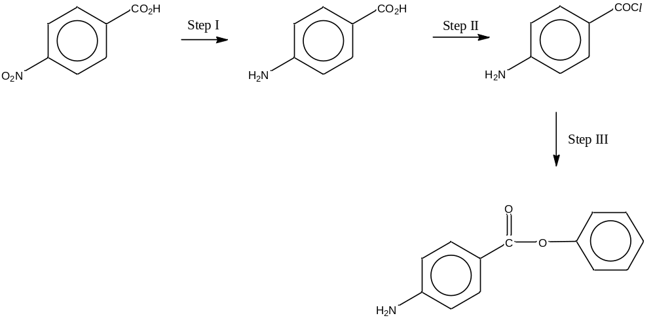  Step I  Sn, concentrated HCl, reflux (followed by NaOH)  Step II  PCl₅, PCl₃, or SOCl₂, r.t.  Step III  C₆H₅OH (with NaOH (aq)), r.t.  OR Step III followed by step II then step I.  (ii) Suggest a chemical test to confirm that phenyl–4–aminobenozate has been formed.  Add aqueous bromine at r.t. to the reaction mixture. If phenyl–4–aminobenozate is present, it will decolourise reddish brown aqueous bromine with a white precipitate formed.  (iii) Explain why 4–nitrobenzoic acid has a higher solubility in water than 4–nitrosalicylic acid.  Due to the close proximity of the –OH and –COOH groups in  4–nitrosalicylic acid, intra–molecular hydrogen bonding can be formed and this decreases the extent of intermolecular hydrogen bond between 4–nitrosalicylic acid and water molecules.  OR  As there is no –OH group in close proximity to the –COOH group in  4–nitrobenzoic acid, intra–molecular hydrogen bonding is not formed. Hence the extent of intermolecular hydrogen bond between 4–nitrobenzoic acid and water molecules is higher than 4–nitrosalicylic acid.  (iv) Draw a diagram of 4–nitrobenzoic acid to illustrate how the shape and bond angles of its nitro group differ from that of the nitronium ion, NO₂⁺ and nitrite ion, NO₂–.  120°  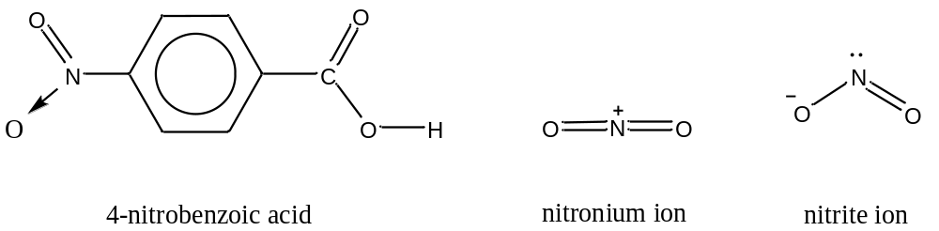  180°  <120°  bent  abt N atom  linear  abt N atom  trigonal planar  abt N atom  [11]
(c) | Dilute solutions of 4–nitrobenzoic acid behaves as weak acids. Aqueous 4–nitrobenzoic acid of concentration 0.1 mol dm^{–3} is only 8% dissociated into ions.  (i) Calculate the pH of 0.1 mol dm^{–3} 4–nitrobenzoic acid.  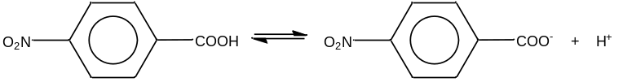  [H⁺] = 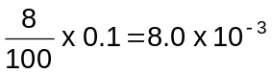 mol dm^{–3}  pH = –log₁₀[H⁺] = –log₁₀(8.0 x 10^{–3}) = 2.10  (ii) Write a K_{a} expression for the acid and define the term pK_{a}.  K_{a} = 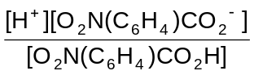  pK_{a} is defined as the negative logarithm to base 10 of the acid dissocation constant, K_{a}  OR pK_{a} = –log₁₀K_{a}  (iii) Calculate the pK_{a} value.  K _{a} = 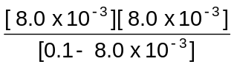 = 0.0006957  pK _{a} = –log₁₀Ka = –log₁₀ (0.0006957) = 3.16  [4]  [Total: 20]

5(a) | 2–chloroethanal, more commonly known as chloroacetaldehyde, is normally used in the control of bacteria and fungi in water and also as a starting reagent to synthesise other organic compounds.  Chloroacetaldehye can be used as a starting material for the synthesis of  3–hydroxypropanoic acid. Propose a reaction scheme, in not more than 3 steps, for this conversion. Your answer should include the reagents and conditions, as well as the structures of the intermediate compounds formed.  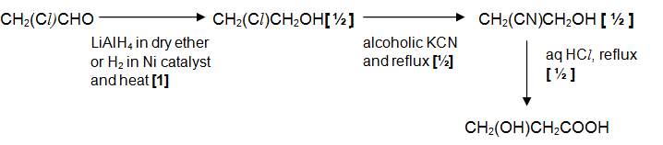  [3]
(b) | A student conducted an experiment by reacting chloroacetaldehye and ethanoyl choride separately with aqueous silver nitrate. It was observed that only ethanoyl choride produced a white precipitate with aqueous silver nitrate.  - Explain this observation, writing balanced equations where necessary.  CH₃COCl + H₂O → CH₃COOH + HCl  Ag⁺ + Cl– → AgCl (white ppt)  Acyl chlorides undergo nucleophilic substitution more readily than alkyl chlorides  due to the relatively larger δ+ charge developed on the carbonyl C atom as a result of electronegative O and Cl atoms  - Describe and explain what will be observed when the white precipitate is added to excess aqueous ammonia.  Ag⁺ (aq) + 2NH₃ (aq) → [Ag(NH₃)₂]⁺ (aq)  Aqueous ammonia combines with silver ions in the solution to form soluble silver (I) diammine complex.  AgCl (s) ⇌ Ag⁺ (aq) + Cl– (aq)  By Le Chatelier’s Principle, equilibrium shifts right to replace the silver ions/increase [Ag⁺]  Hence more AgCl dissolves and a colourless solution is obtained.  [4]
(c) | The liquid–phase oxidation of acetaldehyde, CH₃CHO, at 65°C is used to produce ethanoic acid commercially, with cobalt or manganese ethanoate dissolved in ethanoic acid as a catalyst. With the aid of a suitable diagram, explain how cobalt or manganese ethanoate acts as a catalyst to increase the rate of this reaction.  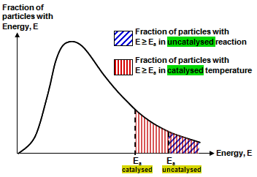  When a catalyst is present, it provides an alternative pathway of lower activation energy.  No. of reactant particles with E ≥ E_{a} increases  Number of effective collisions increases  Since rate of reaction is proportional to the frequency of effective collisions, rate of reaction increases.  [3]
(d) | J is an organic compound with molecular formula C₁₀H₁₃O₂Br. 1 mol of J reacts with 3 mol of aqueous Br₂ to produce a white precipitate K, C₁₀H₁₀O₂Br₄. When refluxed, 0.015 mol of J requires 30 cm³ of 1.0 mol dm^{–3} of aqueous NaOH to produce L and an ionic salt NaBr. However J does not react with aqueous sodium carbonate. Reaction of L with hot acidified KMnO₄ produces M with formula C₁₀H₁₂O₃. All three compounds J, L and M produce a yellow precipitate N when warmed with alkaline aqueous iodine. M forms an orange precipitate with 2,4–dinitrophenylhydrazine but does not react with silver(I) diammine complex.  - Suggest structures for J – N and explain the chemistry involved. Write a balanced equation for the reaction of compound L with aqueous alkaline iodine.  For compound J, C : H ratio ≈1 : 1 and no. of C > 6,  ⇒Compound J has a benzene ring  1 mol of J undergoes easy electrophilic substitution with 3 mol of aq Br₂  ⇒J is a phenol  ⇒side–chain is substituted at the 3– position of benzene ring  1 mol of J requires 2 mol of NaOH for complete reaction to form L  J undergoes neutralisation with NaOH  ⇒J is a phenol  J undergoes nucleophilic substitution with NaOH to form L.  ⇒J is a halogenoalkane (bromoalkane)  J does not undergo neutralisation with aq. Na₂CO₃  ⇒J does not contain –COOH group  L undergoes oxidation with hot acidified KMnO₄ to give M, C₁₀H₁₂O₃.  ⇒L does not undergo side–chain oxidation  ⇒The C atom directly bonded to benzene ring has no H atom attached to it  J, L and M undergoes oxidation with alkaline aq I₂.  ⇒ J, L has CH₃CH(OH)– structure  ⇒M has CH₃CO– structure  M undergoes condensation with 2,4–dinitrophenylhydrazine but no reaction with Tollens’ reagent (silver (I) diammine complex).  ⇒M is a ketone  J: K:  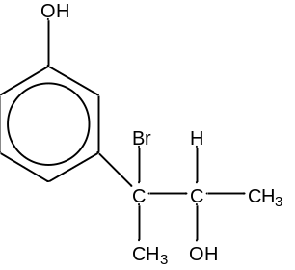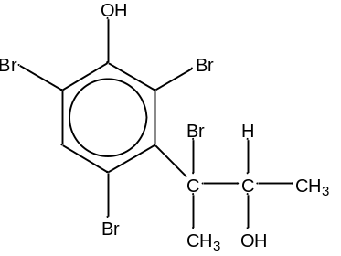  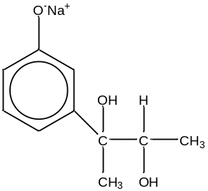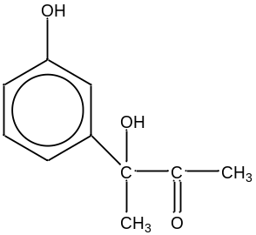 L: M:  N: CHI₃  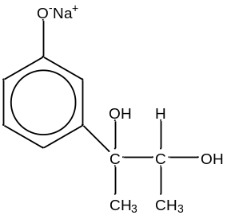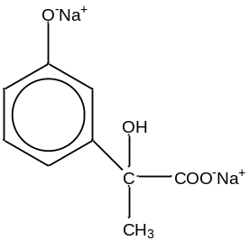Equation:  + 4 I₂ + 6NaOH → + 5NaI + 5H₂O + CHI₃  - Using information from the Data Booklet, predict and explain what will be observed when chlorine gas is bubbled into an aqueous solution of the ionic salt NaBr.  From the Data Booklet,  Cl₂(g) + 2e 2Cl– (aq) E^{θ} = +1.36 V  Br₂(g) + 2e 2Br– (aq) E^{θ} = +1.07 V  E_{cell} = +1.36 – (+1.07)  = +0.29 V > 0  Since E_{cell} > 0, reaction is feasible.  Reddish–brown solution will be seen.  [10]  [Total: 20]

